IT457 Cloud computing

Assignment - 2

Abhinav Agarwal (202101040)

**Complete the following tutorials**:

1. Create a VM using CLI:-

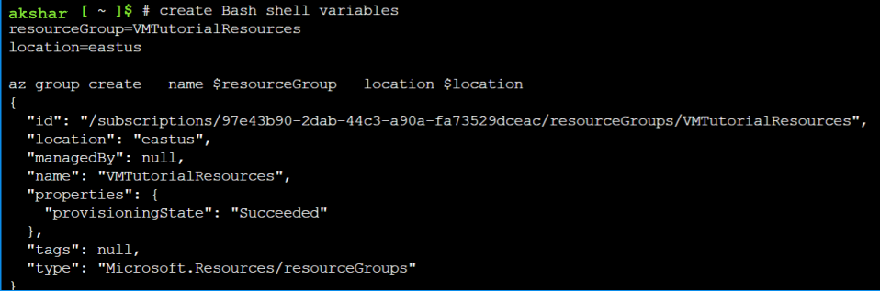

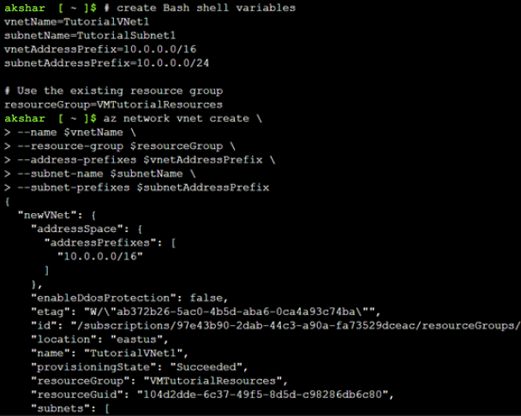

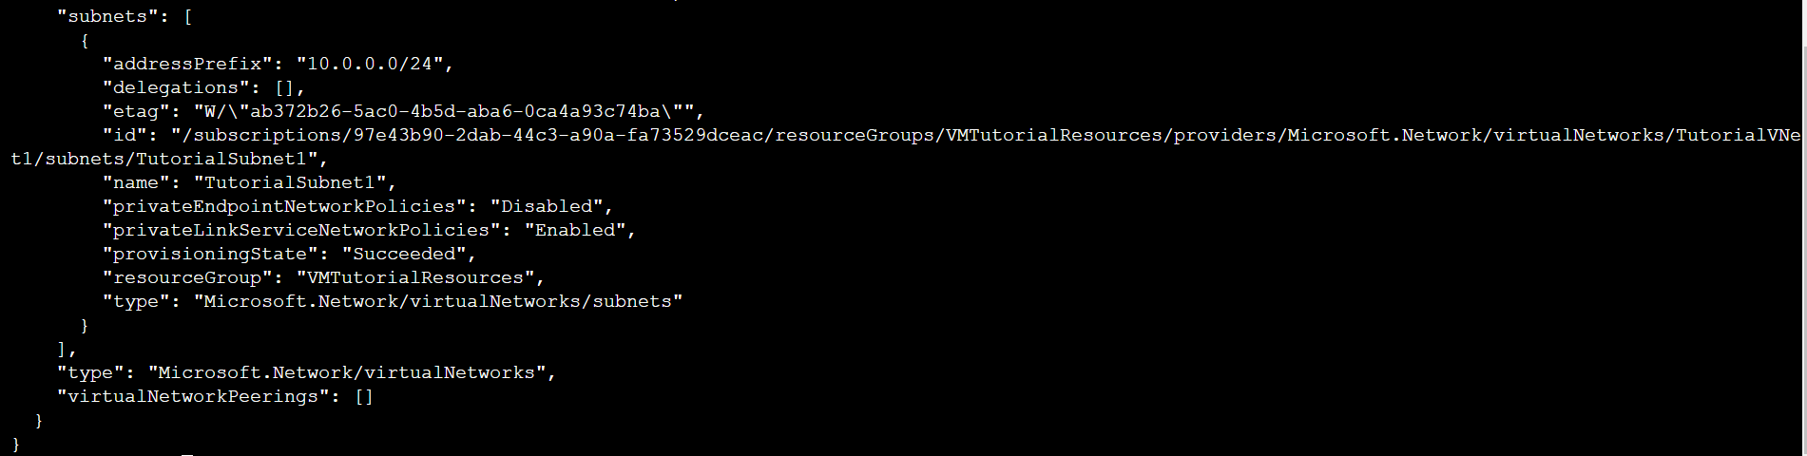

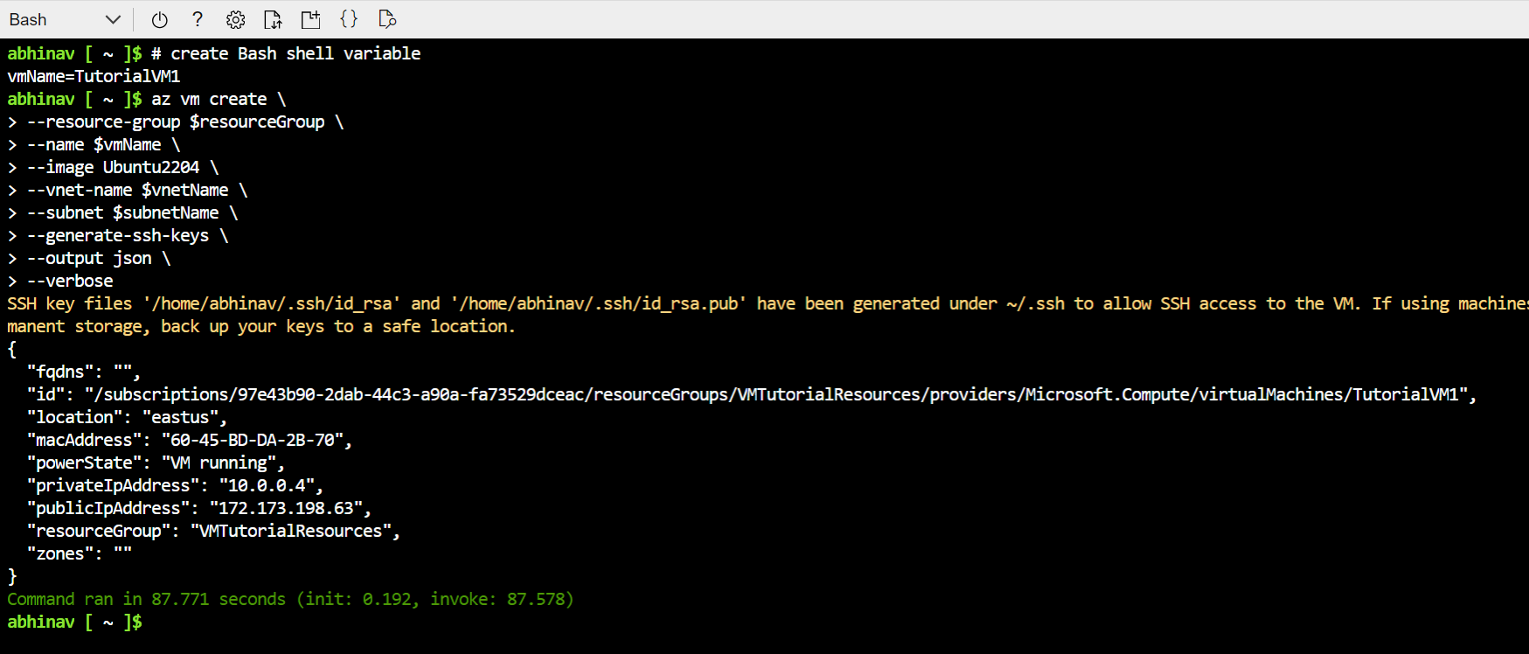

Result:

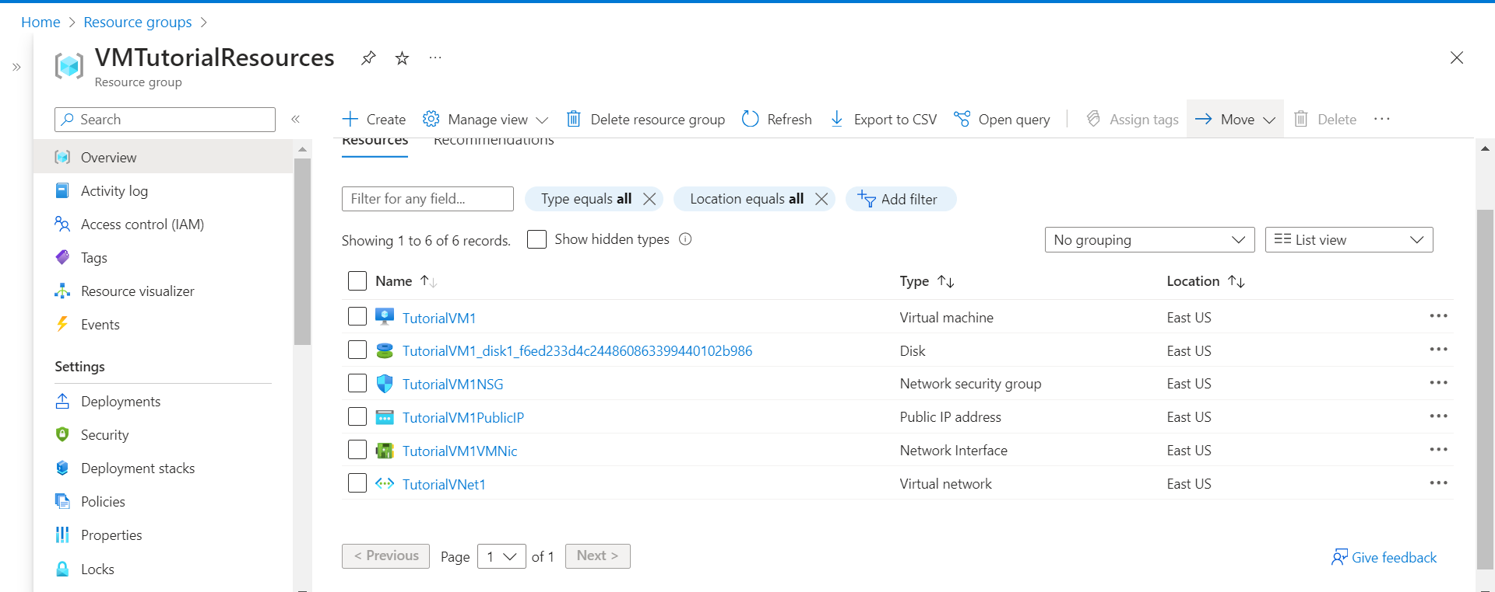

2. Introduction to ARM templates:-

a. Creating first template

JSON:

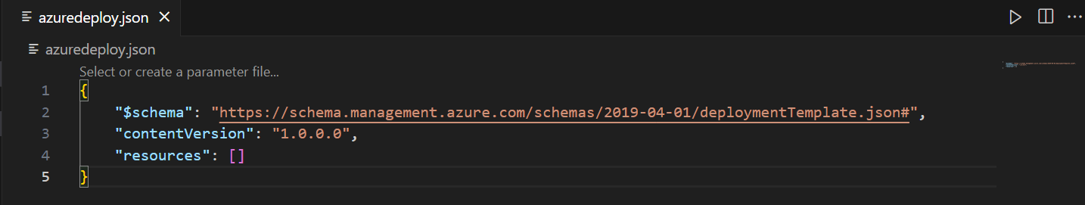

Deployment:

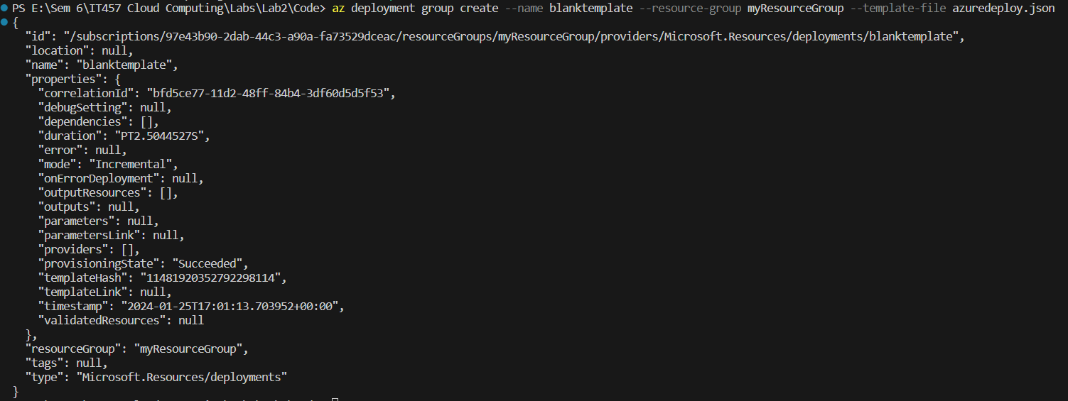

Result:

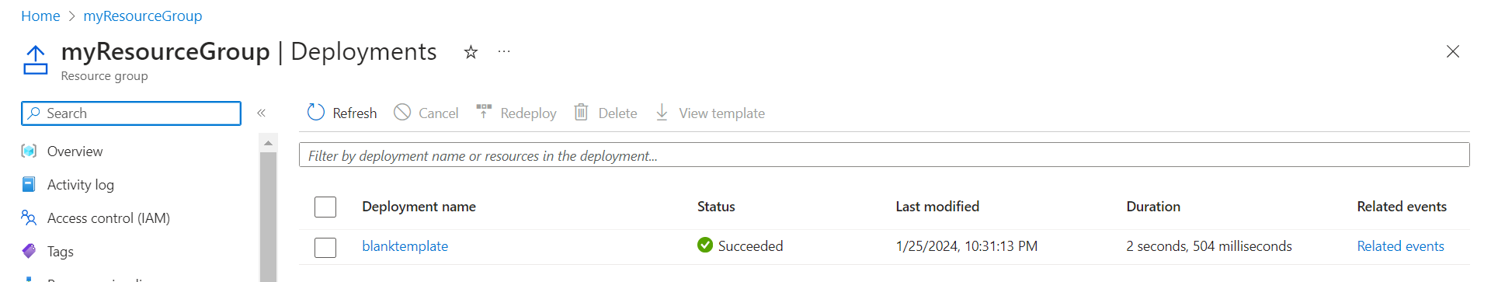

b. Adding resource

JSON:

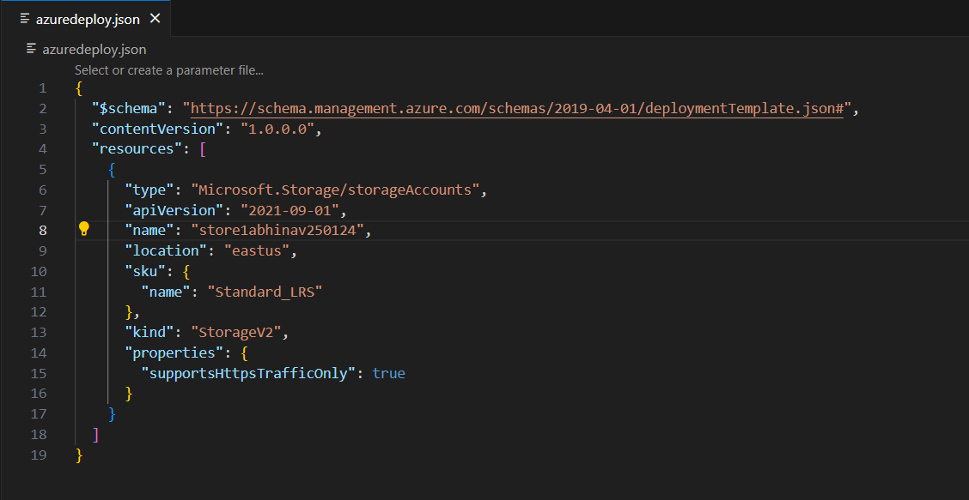

Deployment:

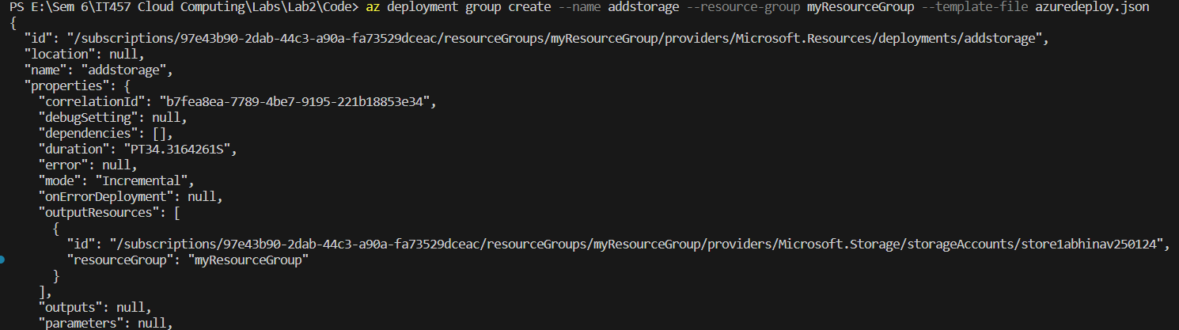

Result:

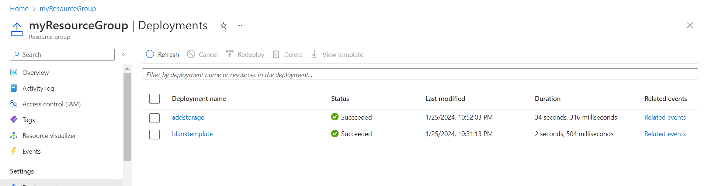

c. Adding parameters

JSON:

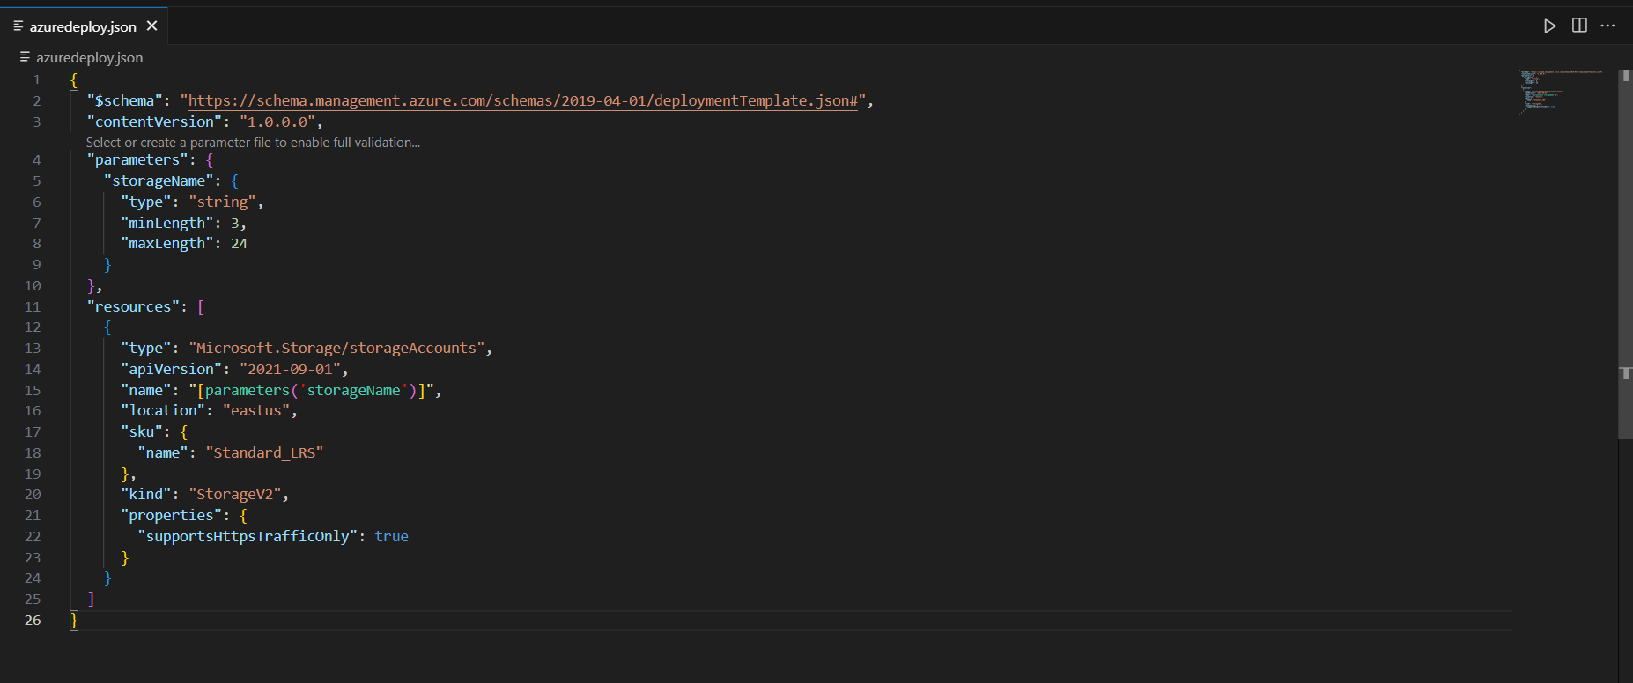

Deployment:

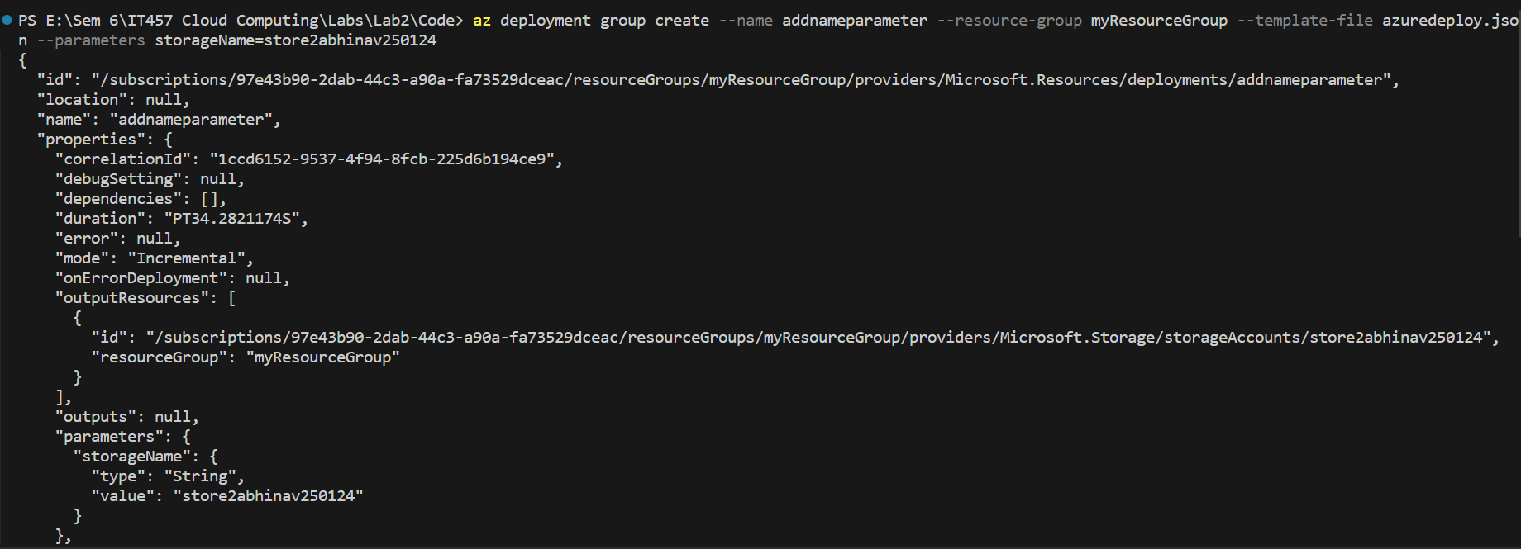

Result:

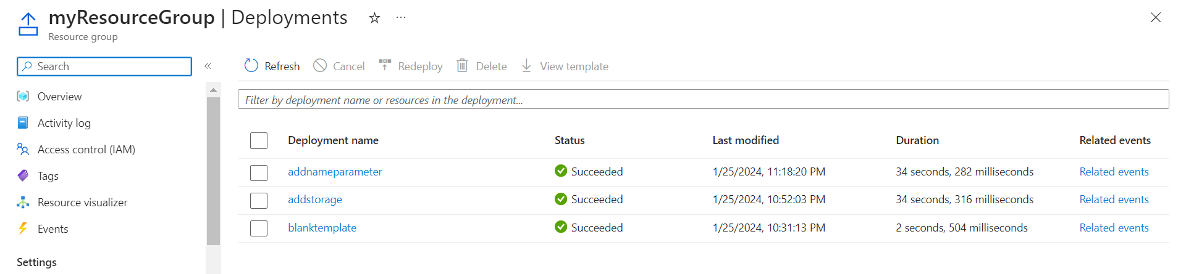

We will redeploy it with SKU parameters:-

JSON:

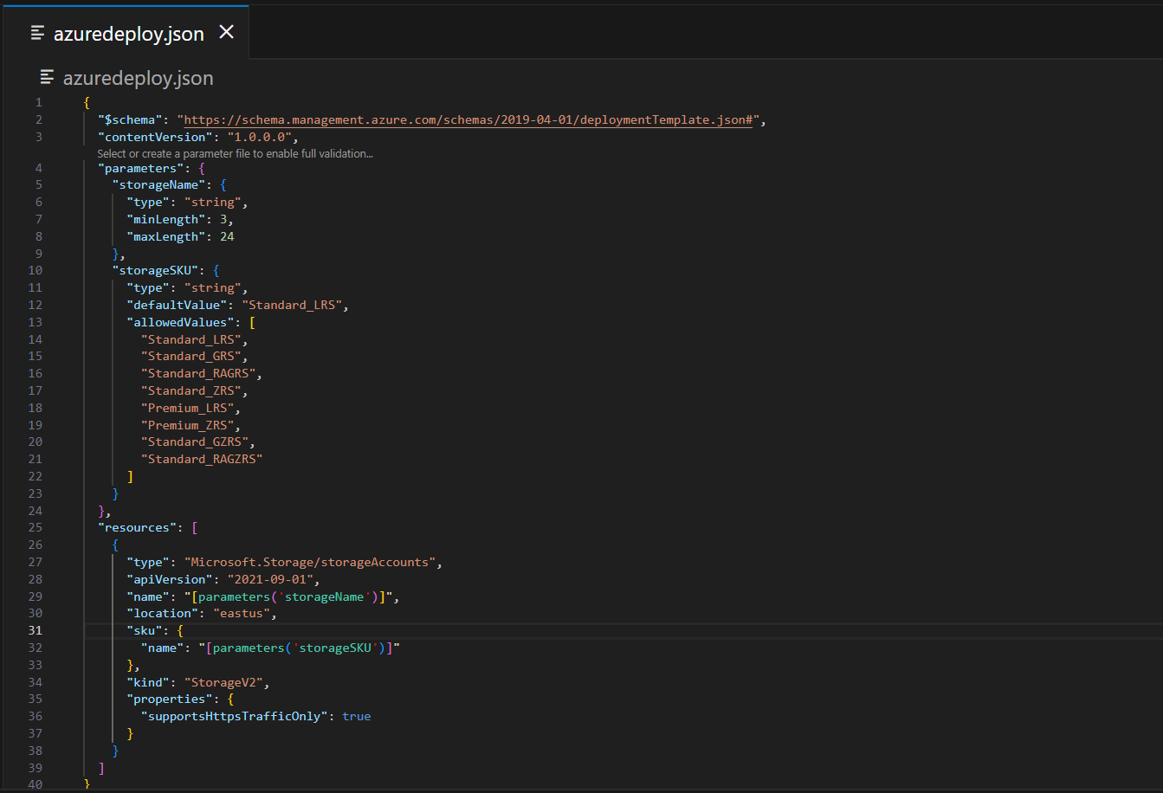

Deployment:

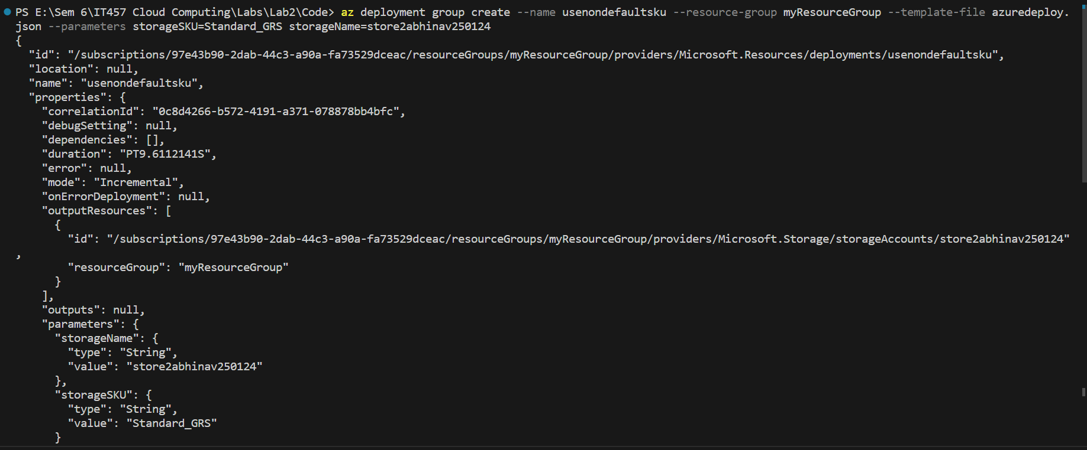

Result:

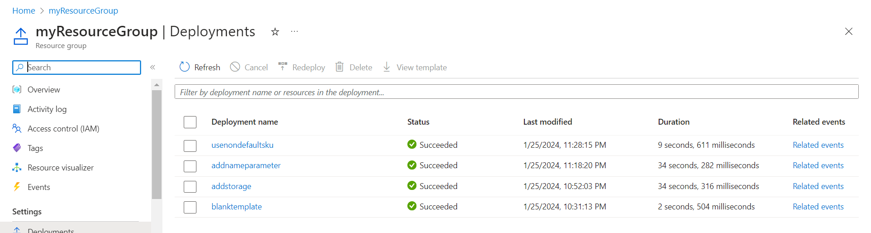

For the parts ahead, I would not be adding screenshots of JSON codes as they are getting very larger.

d. Adding template functions

Deployment:

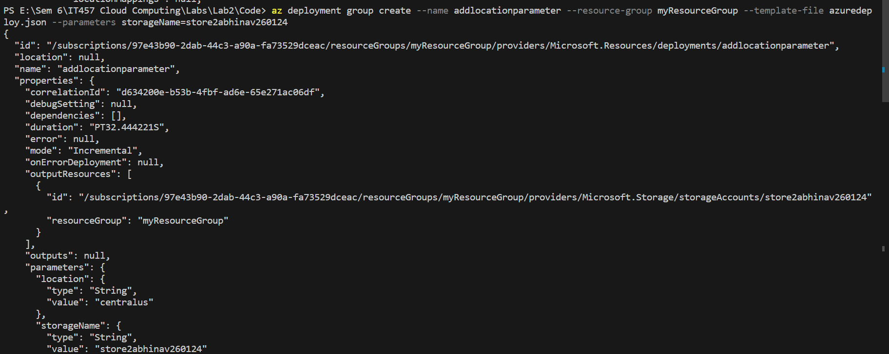

Result:

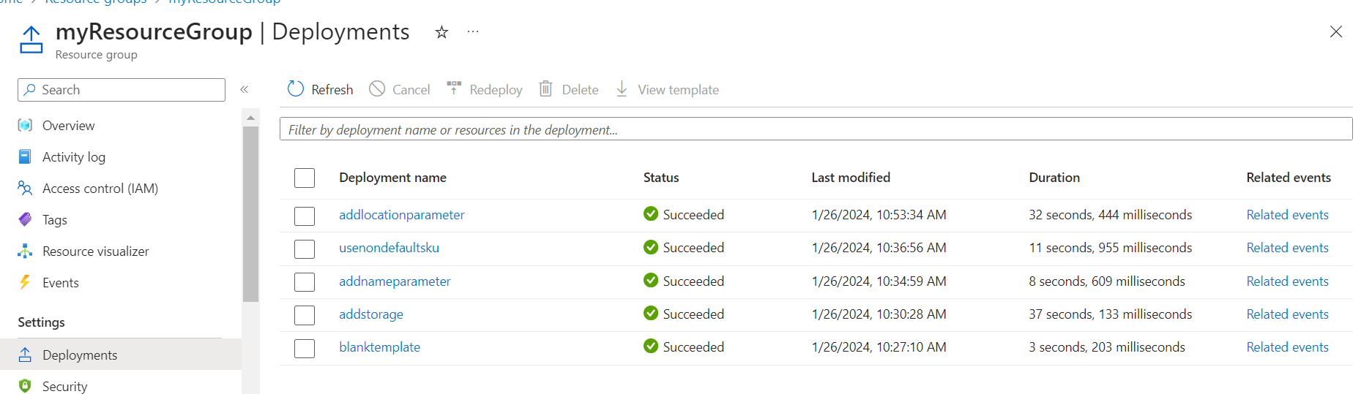

Both resource group and storage account are in some location i.e. Central US.

e. Adding variables

Deployment:

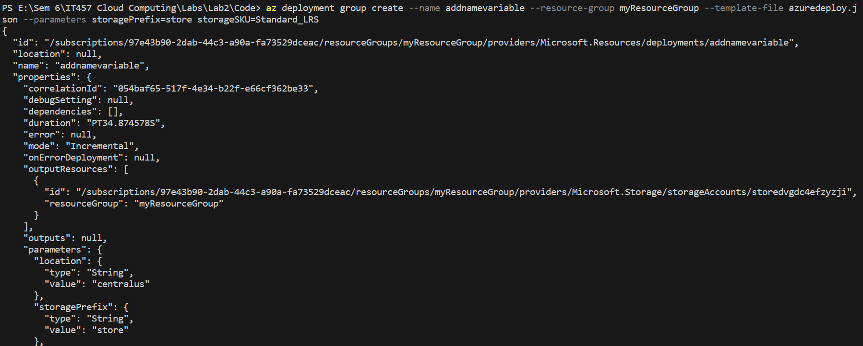

Result:

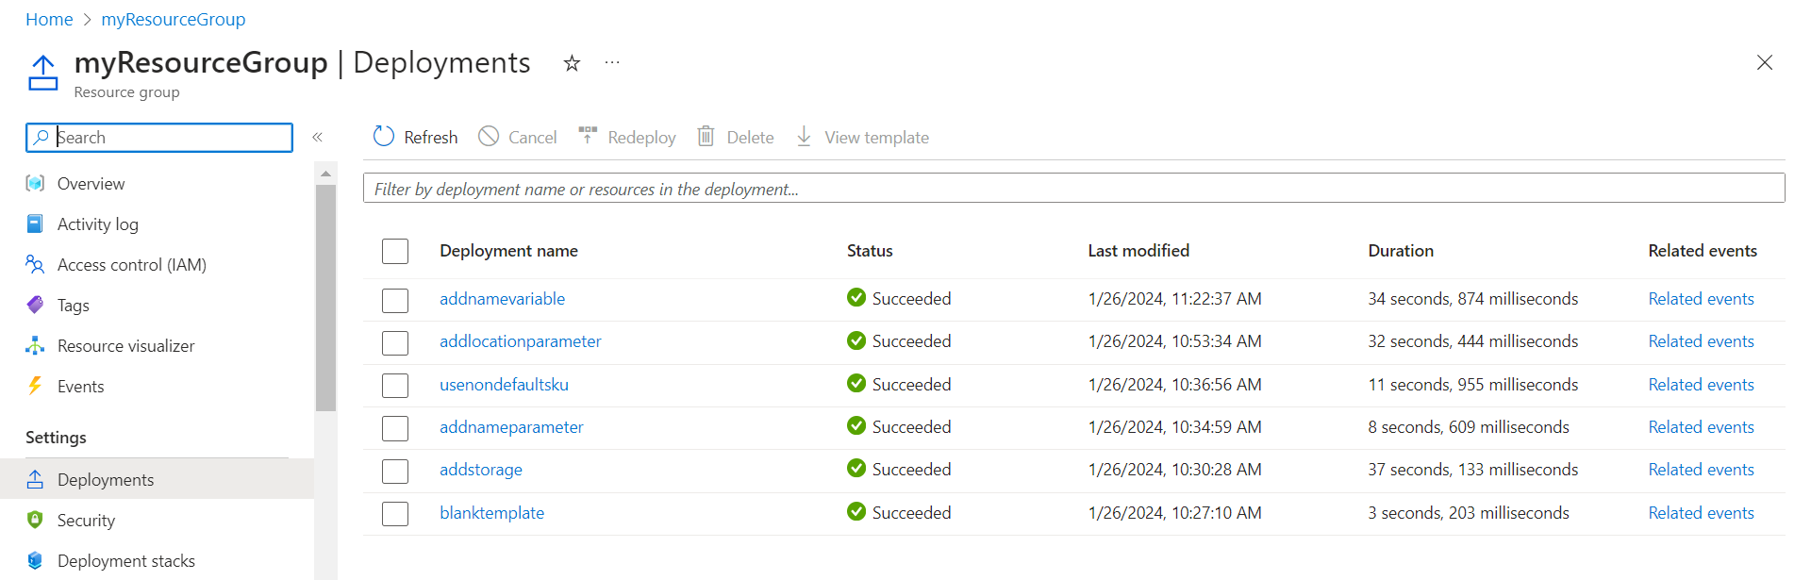



f. Adding outputs

Deployment:

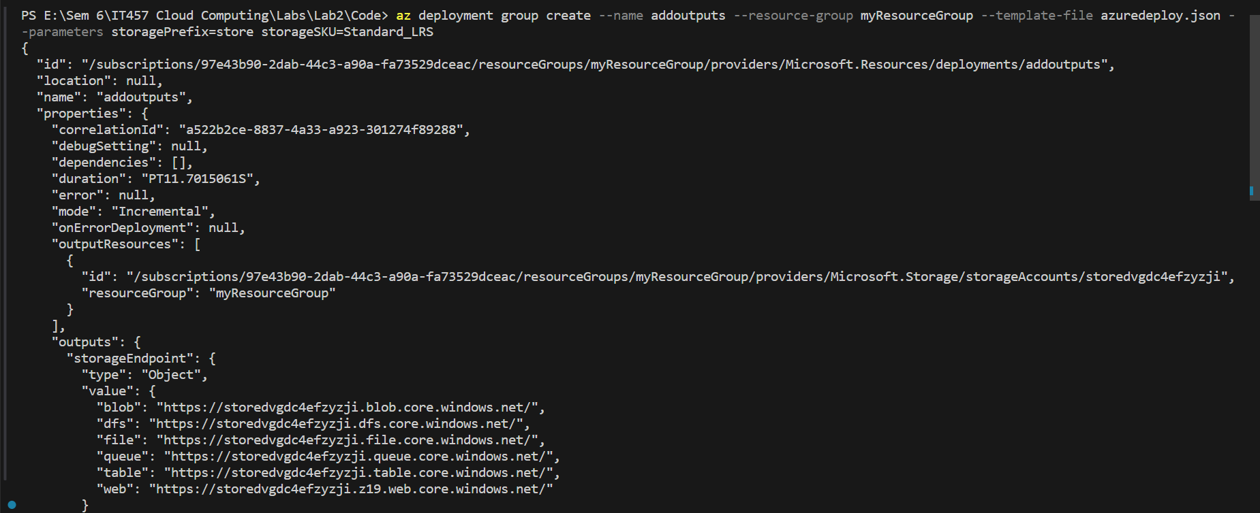

Result:

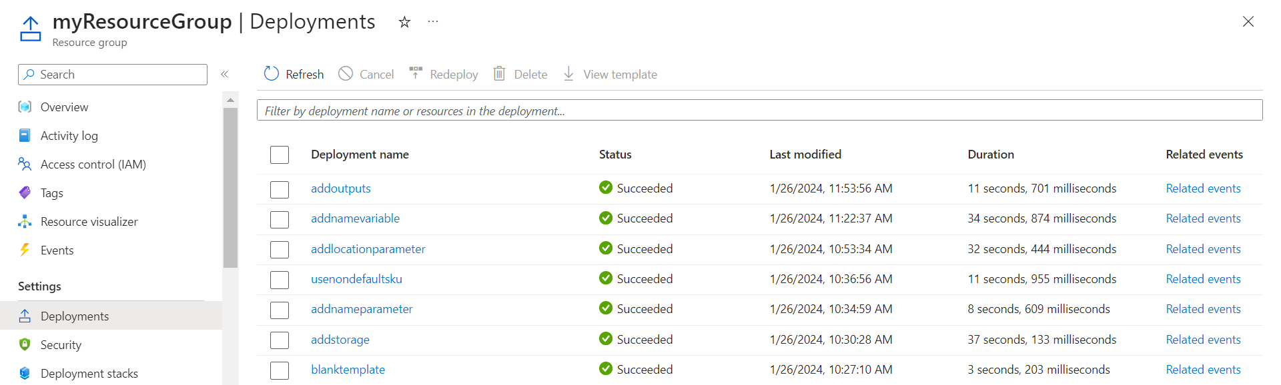

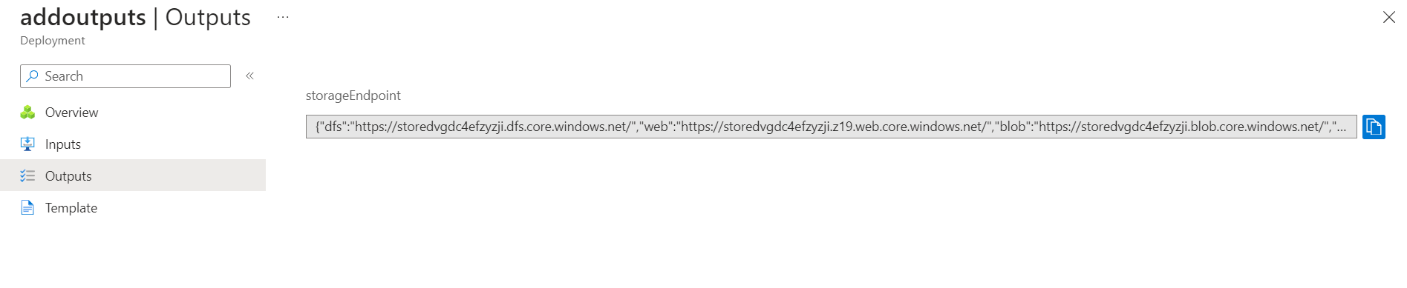

g. Using exported template

Exporting template:

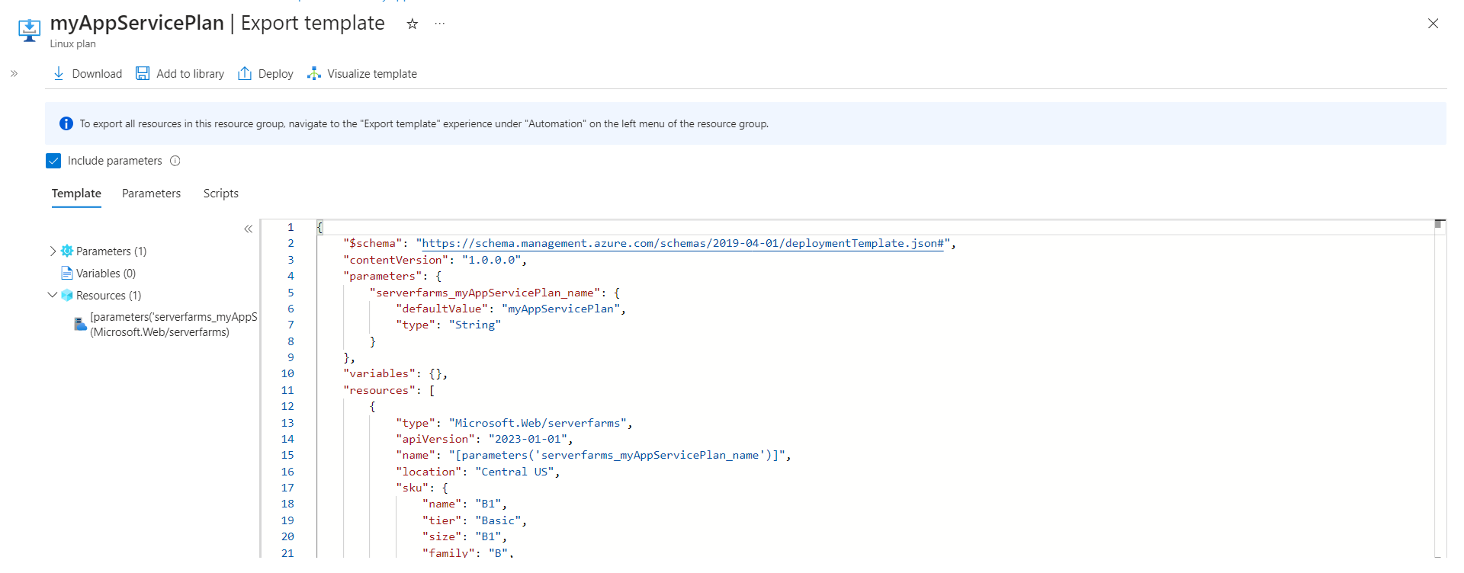

Deployment of revised exported template:

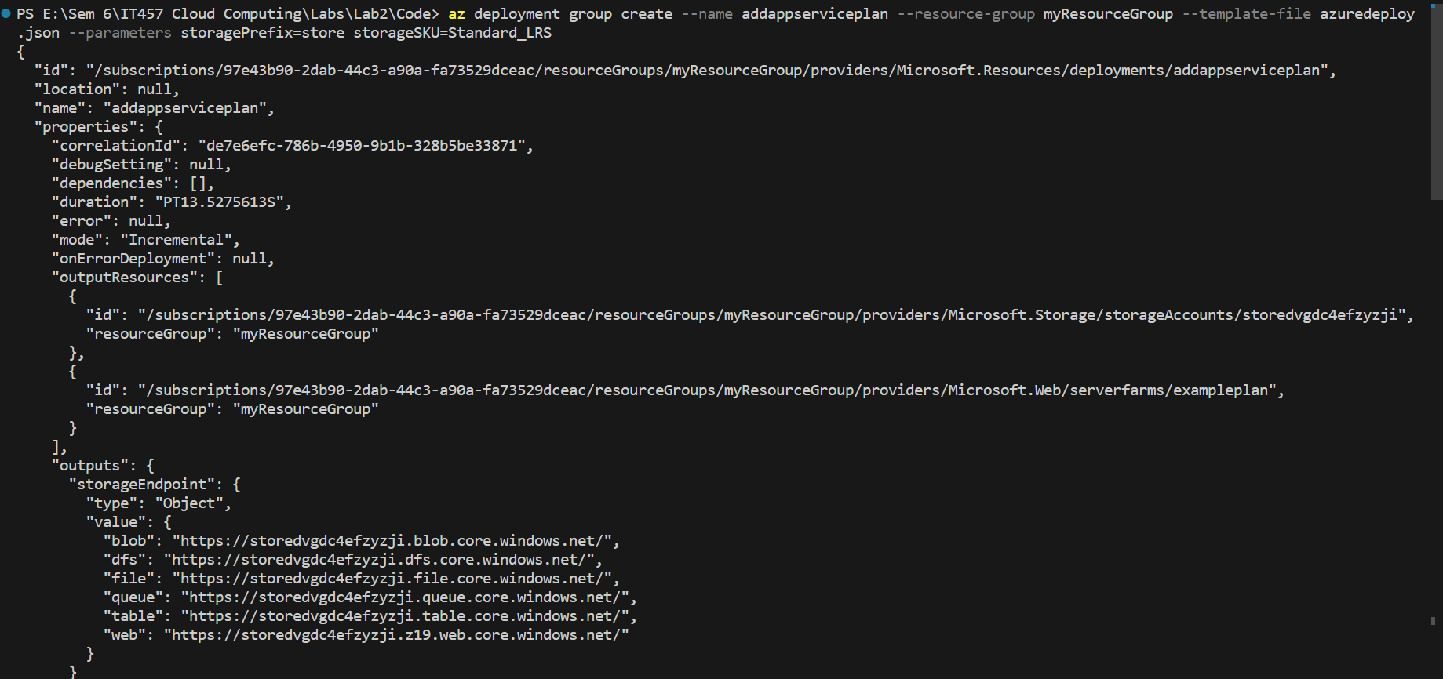

Result:

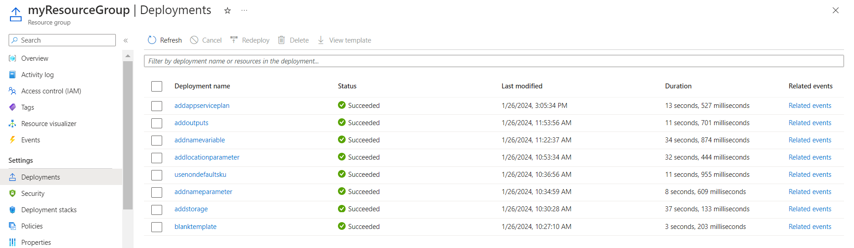



h. Using QuickStart template

QuickStart template:

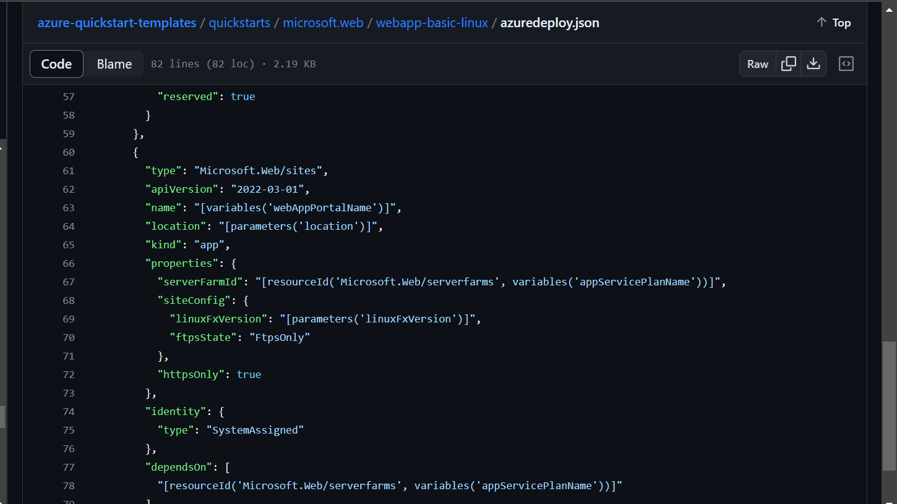

Deployment:

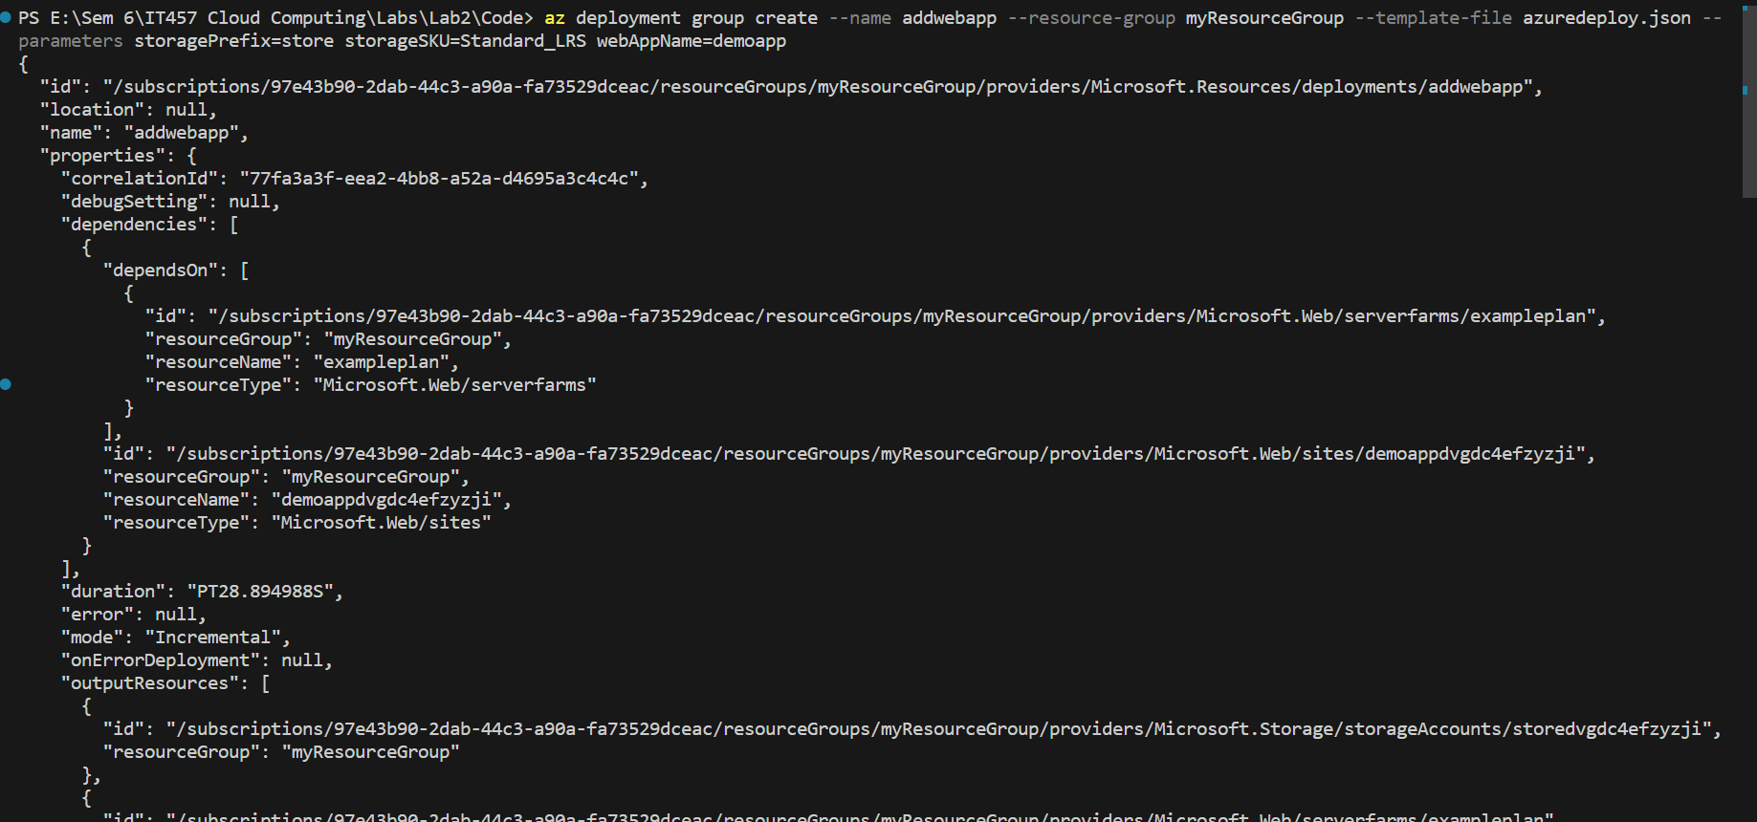

Result:

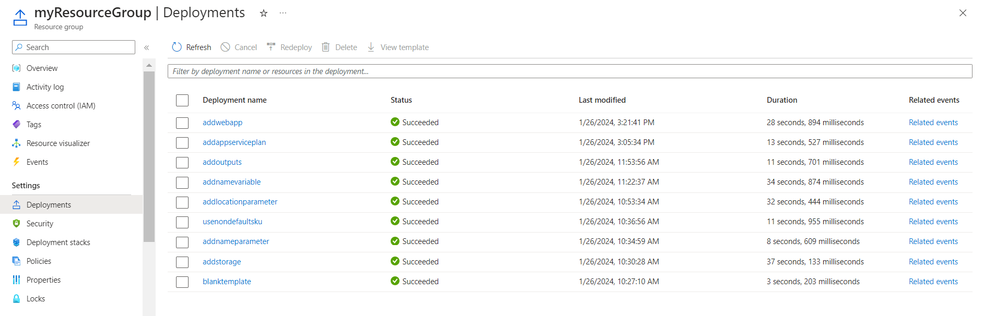



i. Adding Tags

Deployment:

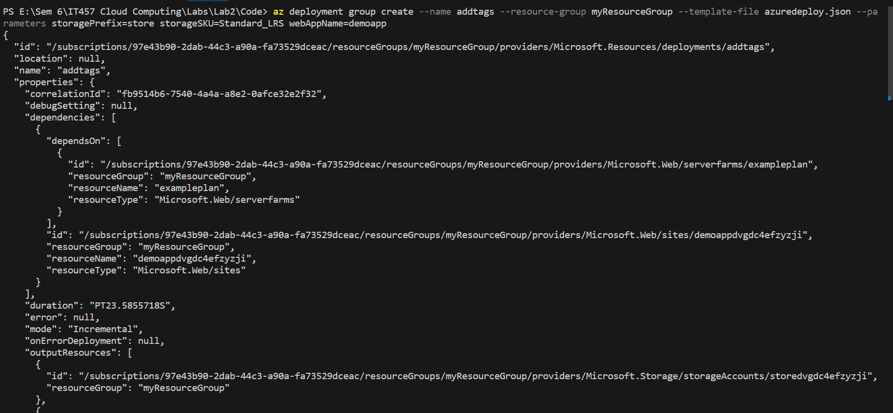

Result:

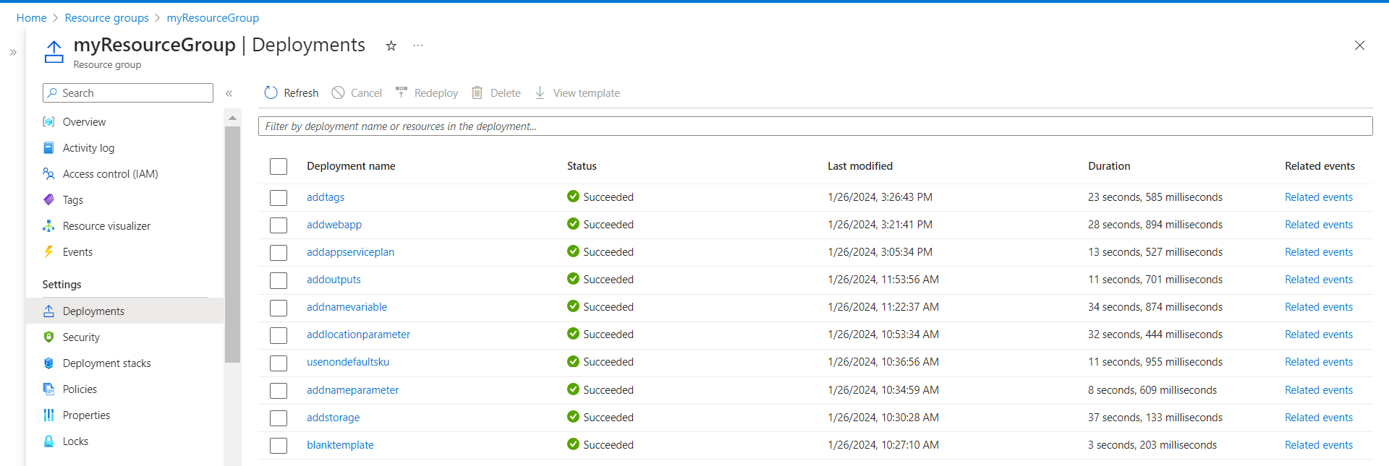

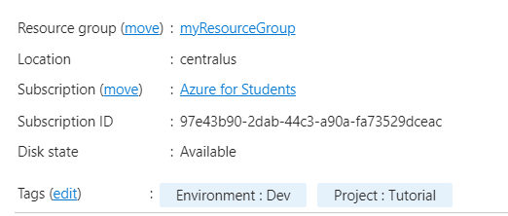

j. Using parameter files

Parameter files:

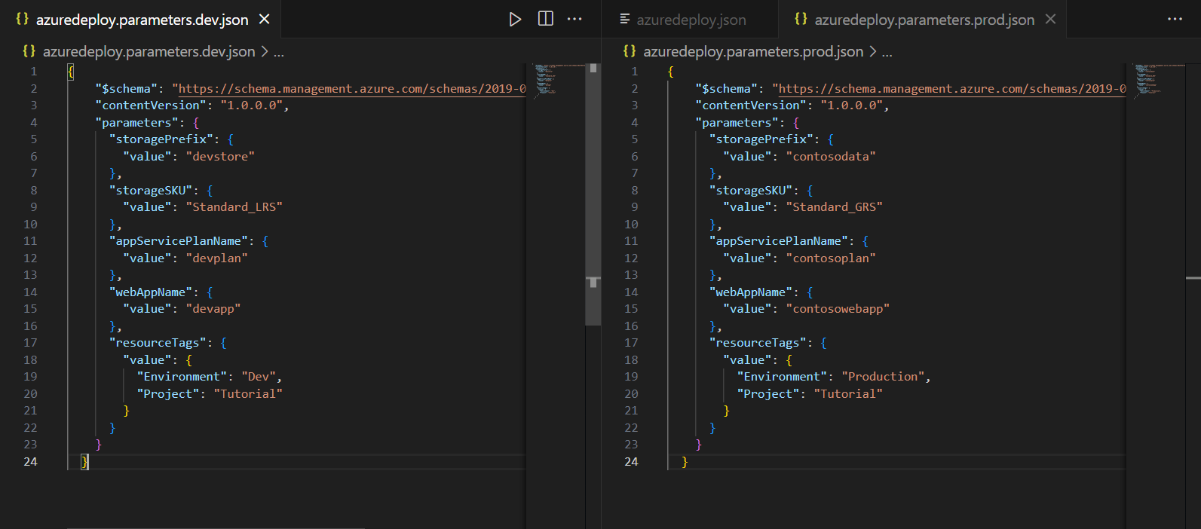

Deployment:

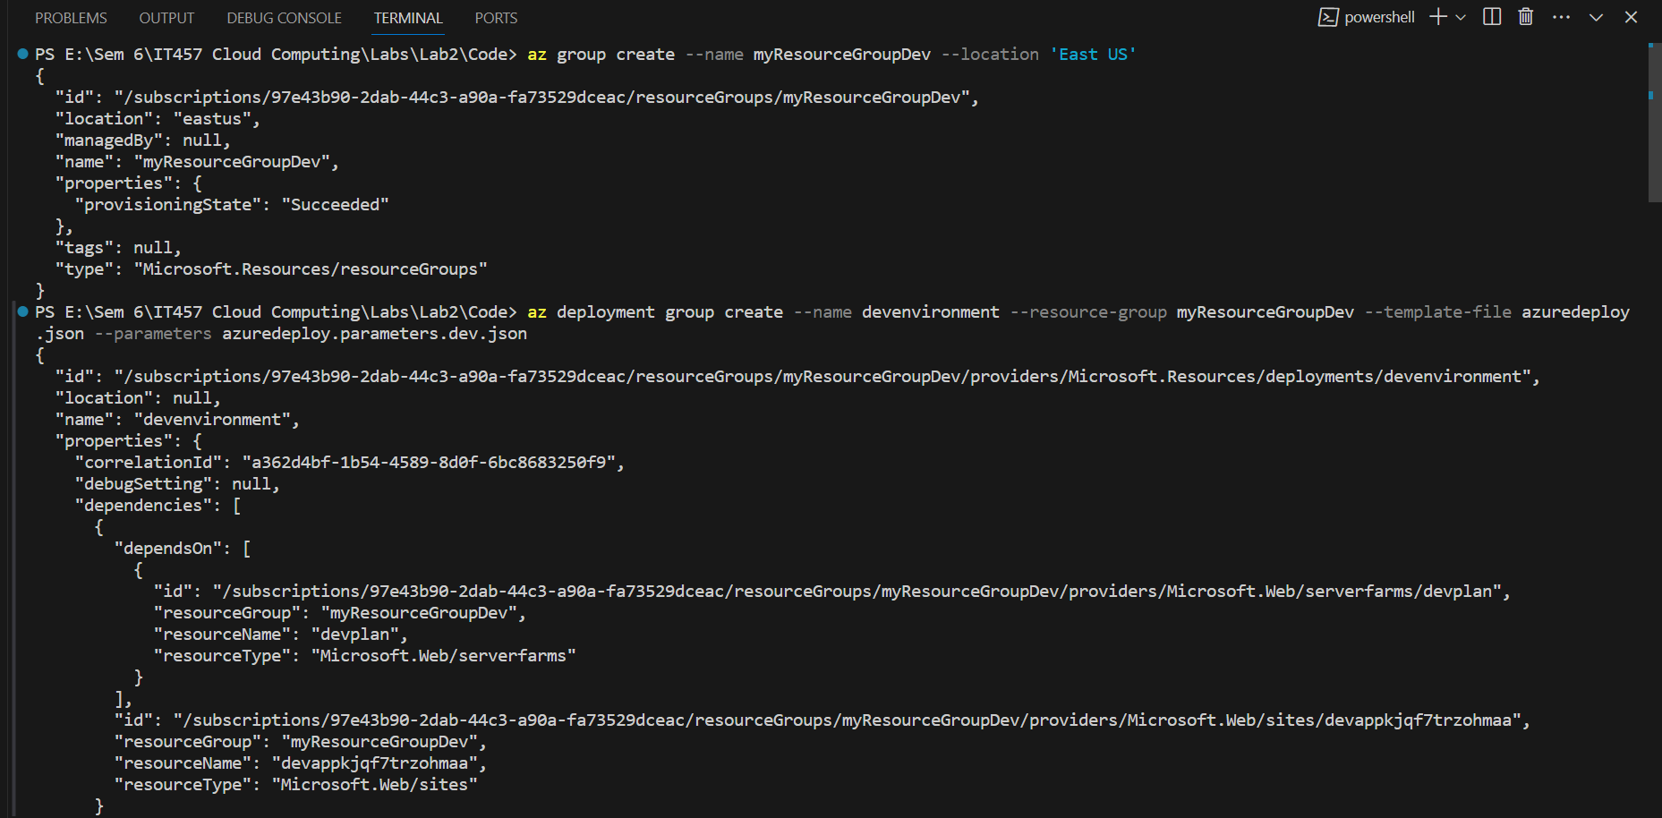

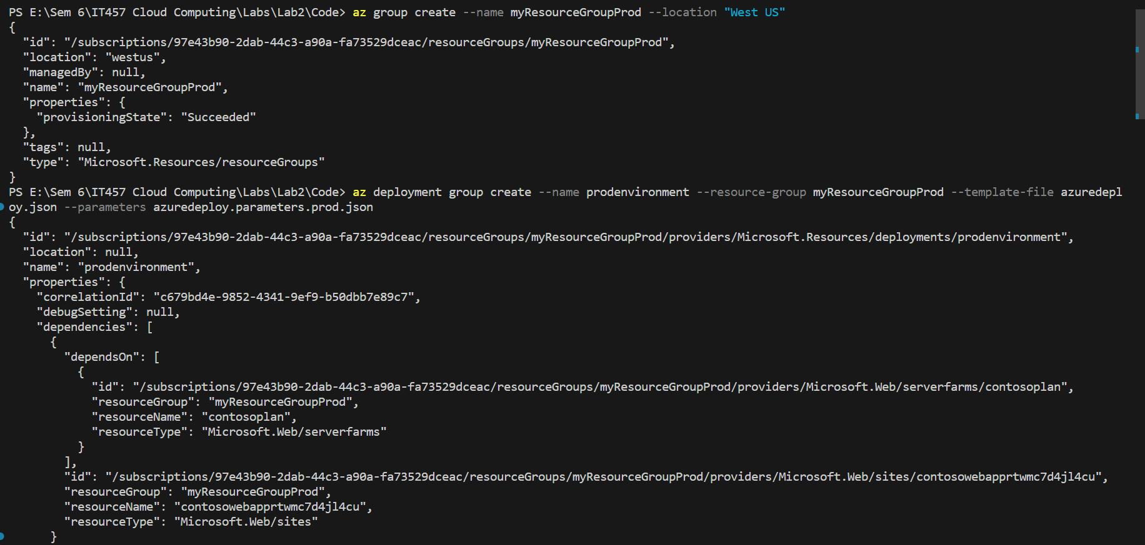

Result:

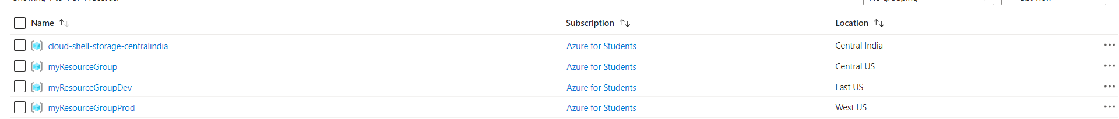

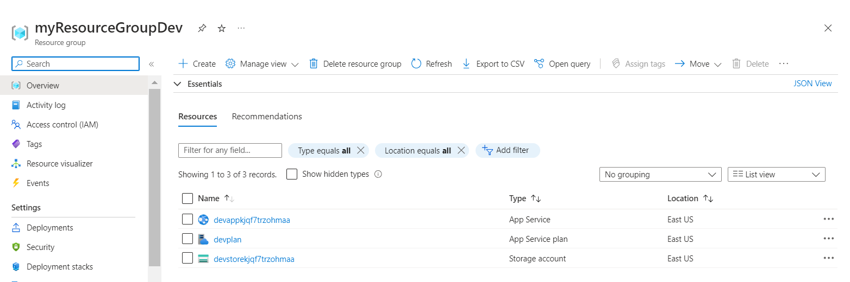

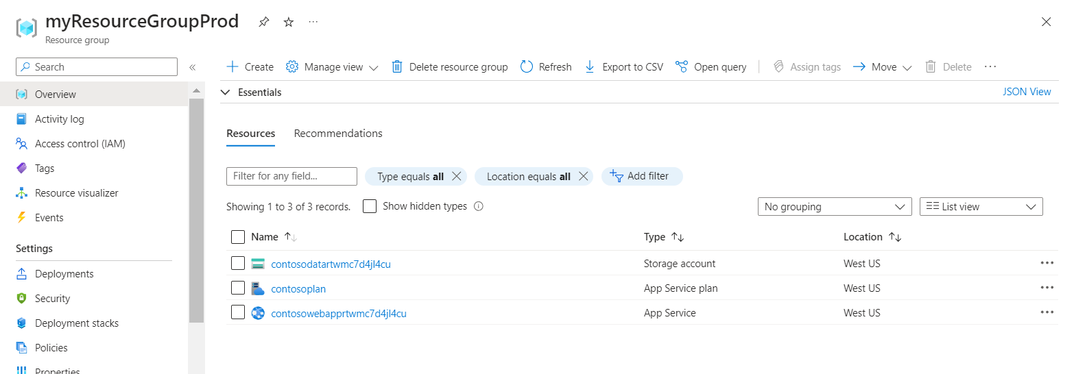

3. N-tier architecture:-

Deployment:

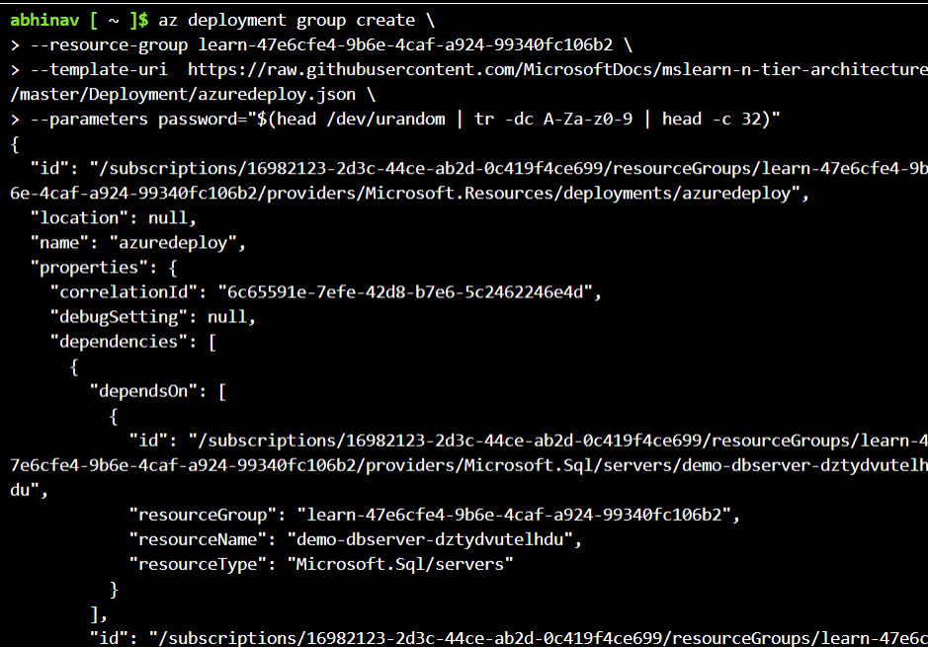

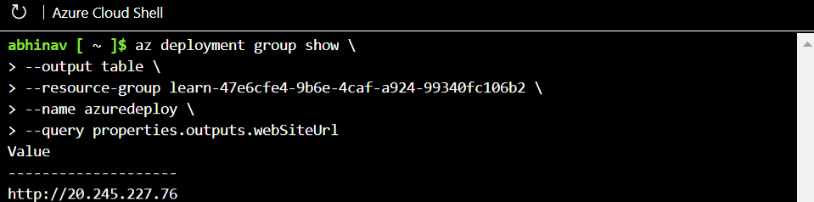

Result:

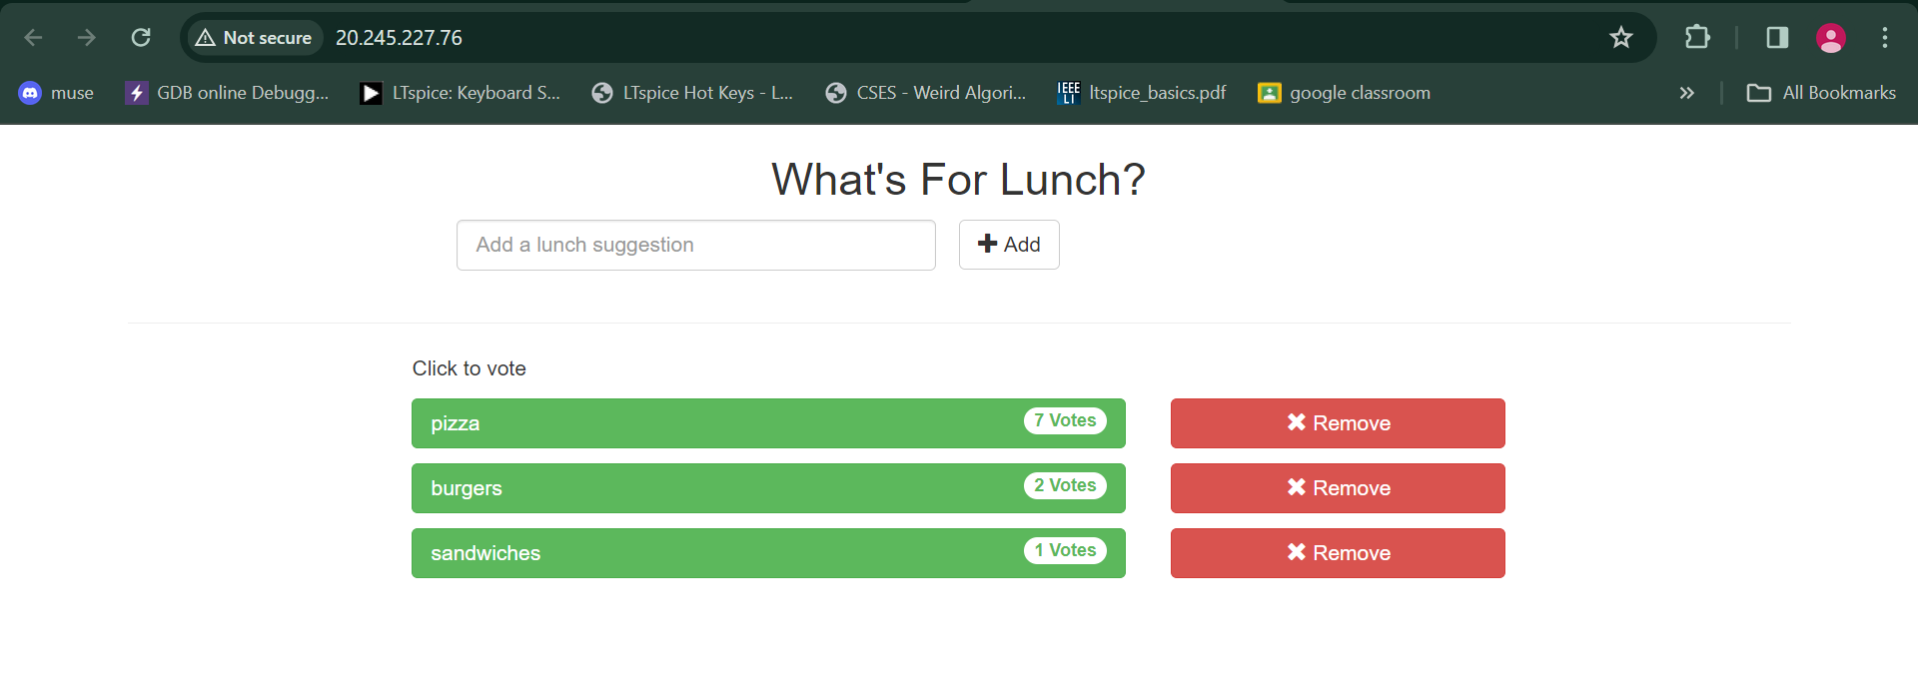

1. Presentation Tier

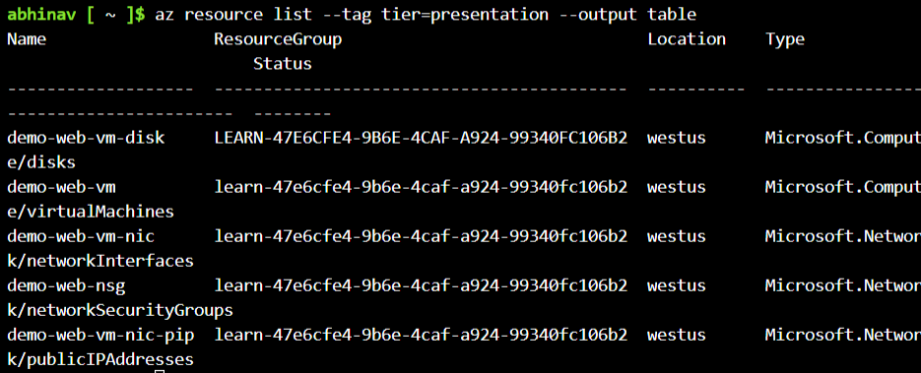

1. Application Tier

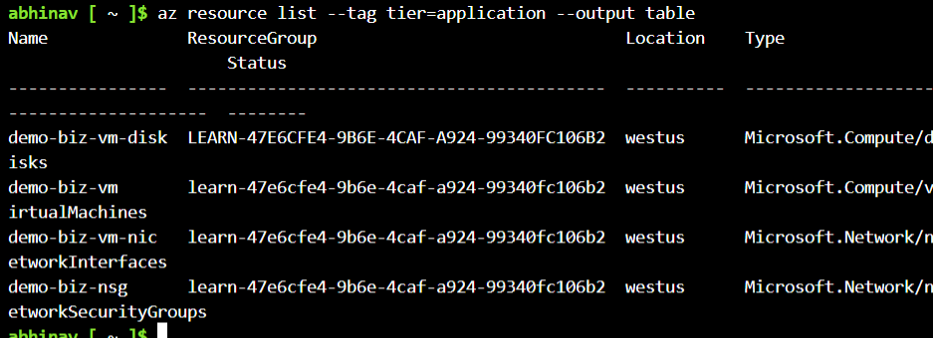

1. Data Tier

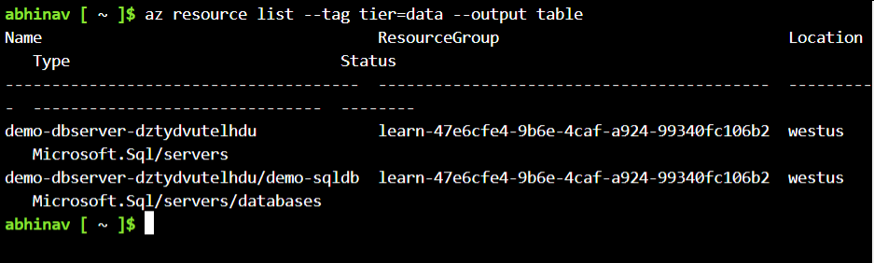

4. Application Gateway Tutorial:-

Resources created:

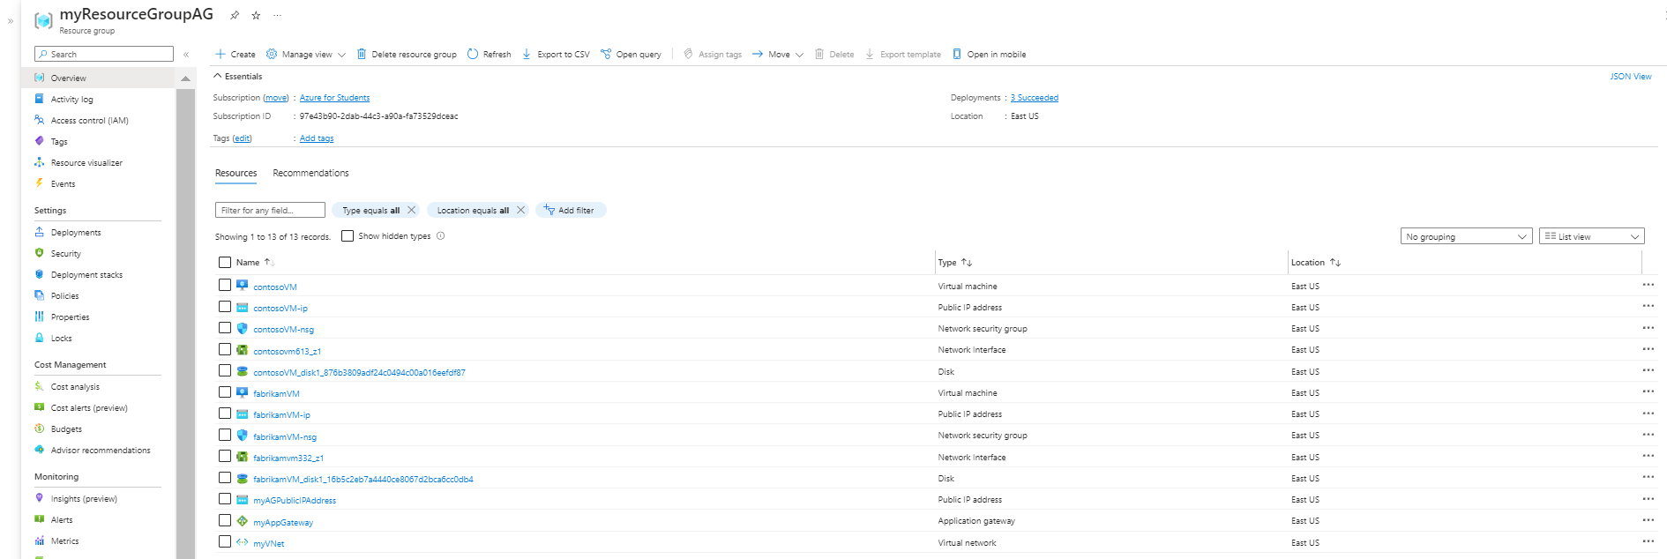

IIS installation:

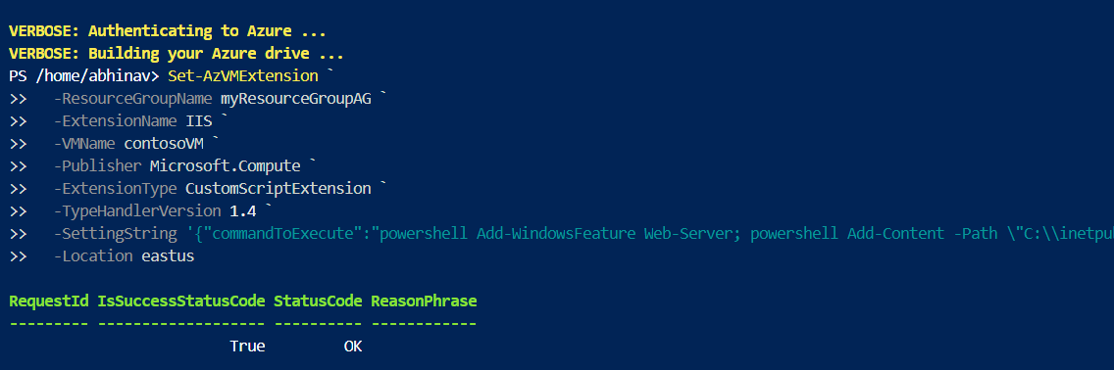

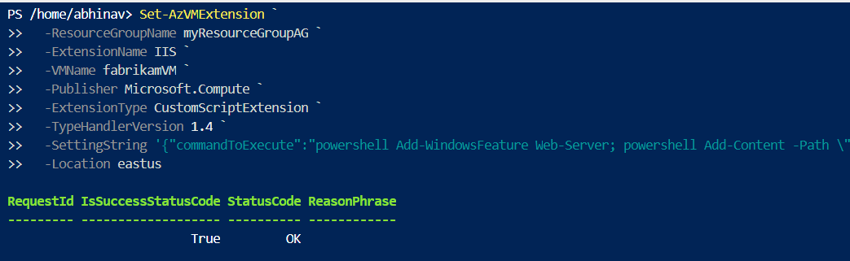

IP Address:

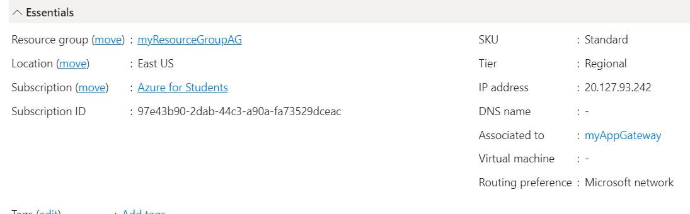

Result:

